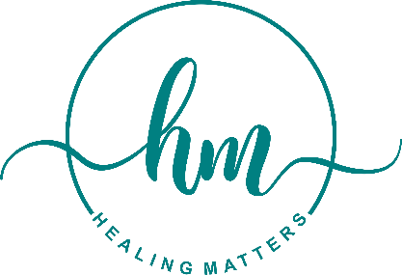

**Position:** Non-Licensed Student Intern **Organization:** Healing Matters Professional Counseling Services  
**Location:** Detroit, MI (Hybrid or In-Person) **Commitment:** 10-15 hours **Compensation:** Unpaid (Academic Credit Available, if applicable), Letter of Reference, Training opportunities

**About Healing Matters:**

Healing Matters is a private practice dedicated to supporting women through life transitions, mental health challenges, and self-preservation. Through therapy, community meetups, and professional development for fellow mental health professionals, we create a space for healing, empowerment, and connection.

We are seeking a non-licensed intern interested in mental health, wellness, and private practice management. This internship provides hands-on experience in community engagement, event coordination, and business development while ensuring ethical and legal boundaries are maintained.

**Responsibilities:**

**Administrative & Operational Support**

* Assist with scheduling, appointment reminders, and client coordination (non-clinical tasks).
* Organize intake forms, client resource materials, and office files.
* Support logistics for Healing Matters Monthly Meetups by coordinating vendors, managing RSVPs, and preparing event materials.
* Help create and schedule social media content (Instagram, Threads) related to mental health, self-care, and personal growth.
* Compile community resource lists and mental health guides for clients.

**Client & Community Engagement**

* Provide non-clinical support at group events, such as greeting guests, setting up materials, and assisting with wellness activities.
* Help build community partnerships with local businesses, schools, and wellness organizations.
* Collect and analyze feedback from clients and event attendees to improve programming.

Business Development & Strategy

* Conduct market research on mental health trends, self-care strategies, and industry best practices.
* Assist in refining the Private Practice Readiness Audit for therapists looking to start their own practice.
* Identify ways to improve efficiency in administrative and operational tasks for a growing private practice.

**Ideal Candidate:**

* A student or recent graduate in psychology, social work, public health, business, or a related field.
* Passionate about mental health, wellness, and community engagement.
* Strong organizational skills with the ability to multitask.
* Creative and resourceful in content creation and social media engagement.
* Comfortable interacting with diverse populations and maintaining confidentiality.
* Ability to work both independently and collaboratively in a professional setting.

**Internship Benefits:**

* Hands-on experience in private practice operations, wellness event planning, and business strategy.
* Opportunities to attend Healing Matters events and network with mental health professionals.
* Professional development in mental health business management and community engagement.
* Academic credit (if applicable) and a letter of recommendation upon successful completion.

**How to Apply:**

Interested candidates should submit a resume and a short statement of interest (250 words max) outlining their experience and why they are interested in interning at Healing Matters. Applications can be sent to info@myhealingmatters.com with the subject line “Healing Matters Internship Application.”